EXERCISE 4: Database Normalization – Doctor & Patient Appointment
Original Table: SURGERY_SCHEDULE
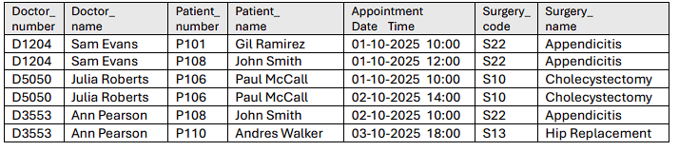
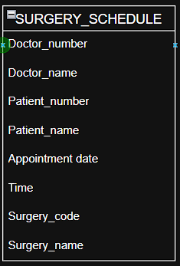
STEP 1: First Normal Form (1NF)
1.1.Rule 1NF
- The first normal form (1NF) requires:
- “Each attribute must contain only a single value".
- "Each attribute must be atomic (not be a combination of multiple columns)"
1.2.Issue
- The table has repeating data (Doctor, Surgery, Patient repeated many times).
- But no multi-valued attributes — so it’s technically in 1NF, but not well-structured (repetition leads to anomalies).
1.3.Solution
- We identify a unique composite key: {Doctor_number, Patient_number, Appointment_Date, Time} – This uniquely identifies each appointment.
- All values are atomic => so the table is now 1NF.
1.4.PK and FKS
The PK for the SURGERY_SCHEDULE table is a unique composite key: {Doctor_number, Patient_number, Appointment_Date, Time}.
1.5.ERDs
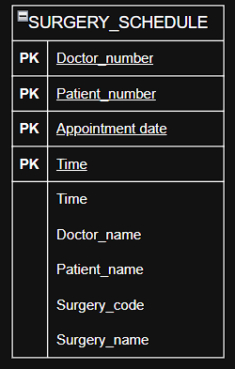
1.6.Example data
PK: Doctor_number | PK: Patient_number | PK: Appointment_Date | PK: Time | Doctor_name | Patient_name | Surgery_code | Surgery_name
D1204 | P101 | 01-10-2025 | 10:00 | Sam Evans | Gil Ramirez | S22 | Appendicitis
D1204 | P108 | 01-10-2025 | 12:00 | Sam Evans | John Smith | S22 | Appendicitis
D5050 | P106 | 01-10-2025 | 10:00 | Julia Roberts | Paul McCall | S10 | Cholecystectomy
D5050 | P106 | 02-10-2025 | 14:00 | Julia Roberts | Paul McCall | S10 | Cholecystectomy
D3553 | P108 | 02-10-2025 | 10:00 | Ann Pearson | John Smith | S22 | Appendicitis
D3553 | P110 | 03-10-2025 | 18:00 | Ann Pearson | Andres Walker | S13 | Hip Replacement

1.7.Reflections
- Table is in 1NF because:
- No repeating groups.
- All fields atomic.
- But still redundant – e.g., Sam Evans repeated multiple times for D1204 => violates 2NF.

STEP 2: Second Normal Form (2NF)
2.1 Rule (2NF)
- Must be in 1NF.
- All non-key attributes must depend on the whole primary key (no partial dependency).
2.2 Issue
- In 1NF table:
- Doctor_name depends only on Doctor_number.
- Patient_name depends only on Patient_number.
- Surgery_name depends only on Surgery_code.
- These are partial dependencies, so the table is not in 2NF.
2.3 Solution
- Split the table into separate entities
1. DOCTOR (Doctor info)
2. PATIENT (Patient info)
3. SURGERY (Surgery info)
4. APPOINTMENT (Linking Doctor, Patient, Surgery and Date/Time)
2.4 PK and FKs
- The primary key for DOCTOR table is the Doctor_number.
- The primary key for PATIENT table is the Patient_number.
- The primary key for SURGERY table is the Surgery_code.
- The primary key for APPOINTMENT table is the Appointment_Date and Time.
- Doctor_number, Patient_number, Surgery_code are FKs in APPOINTMENT table.
2.5 ERDs
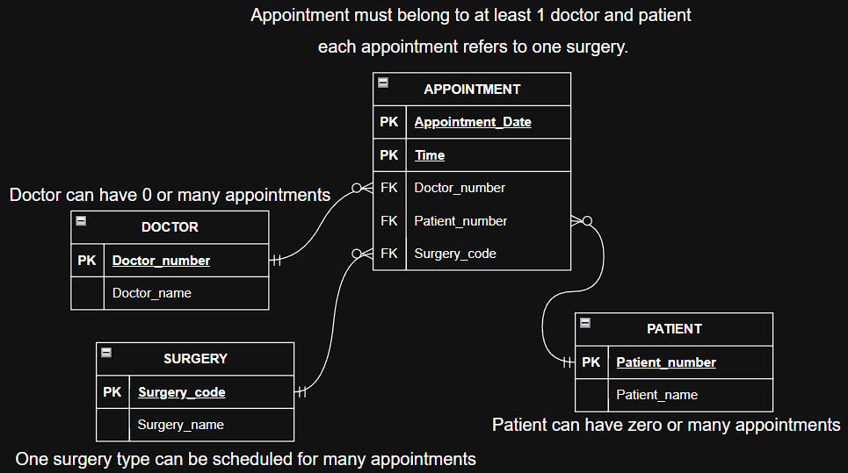

2.6 Sample data
DOCTOR
PK: Doctor_number | Doctor_name
D1204 | Sam Evans
D5050 | Julia Roberts
D3553 | Ann Pearson
PATIENT
PK: Patient_number | Patient_name
P101 | Gil Ramirez
P108 | John Smith
P106 | Paul McCall
P110 | Andres Walker

SURGERY
PK: Surgery_code | Surgery_name
S22 | Appendicitis
S10 | Cholecystectomy
S13 | Hip Replacement

APPOINTMENT
PK: Doctor_number (FK) | PK: Patient_number (FK) | PK: Appointment_Date | PK: Time | FK: Surgery_code
D1204 | P101 | 01-10-2025 | 10:00 | S22
D1204 | P108 | 01-10-2025 | 12:00 | S22
D5050 | P106 | 01-10-2025 | 10:00 | S10
D5050 | P106 | 02-10-2025 | 14:00 | S10
D3553 | P108 | 02-10-2025 | 10:00 | S22
D3553 | P110 | 03-10-2025 | 18:00 | S13

2.7 Reflections
- All non-key attributes now depend on the full PK.
- Redundancy reduced.
- But still possible transitive dependency (e.g., Surgery_name depends on Surgery_code, which depends on Appointment).
STEP 3: Third Normal Form (3NF)
3.1 Rule (3NF)
- Must be in 2NF
- All non-key attributes must depend only on the primary key (no transitive dependency)
3.2 Issue
- Our design already separates dependencies — there are no transitive dependencies left.
Each non-key column depends only on its table’s PK.
3.3 Solution
The structure from 2NF already satisfies 3NF — this is the final normalized form.
3.4, 3.5, 3.6 same like step 2
3.7 Reflection
- All redundancy eliminated.
- No multi-valued or derived fields.
- All tables in 3NF.
- Primary and foreign keys defined correctly.

